ST. AUGUSTINE HIGH SCHOOL

Academy of Law and Homeland Security
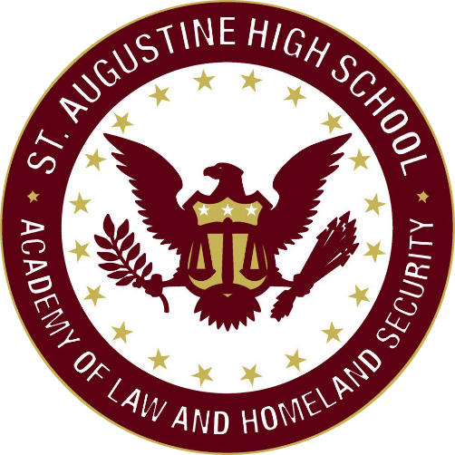
Sherry Gaynor, Program Specialist
sherry.gaynor@stjohns.k12.fl.us
904-547-8538

Program Highlights:
- Law Enforcement Industry Professional Instructors
- Florida Public Service Association Membership, Competitions, and Club Activities
- 911 Dispatch Industry Certification
- Service-Learning Opportunities through Internship
- High-Tech Lab Activities for Crime Scene and Criminal Justice Operations

